Q1 a).Create a new table to track the Post_Office location. Post_Office (po_id, po_name, po_address, _city, po_state, po_pincode) po_id is the primary key and should be numeric. po_name, po_address, and po_city is between 1 and 35 characters. – These should not be null. po_state is 2 characters po_pincode is 5 numbers. Check for one of the following pin codes – 75081, 75080, 75082, 75079, 75078

b). Write insert query for the above table (Post_Office). Enter 5 rows in the table.

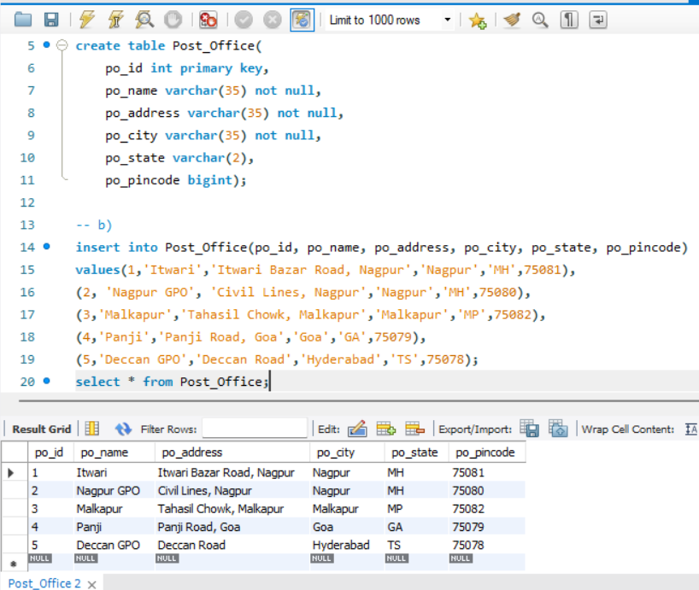

c). Write a query that will display all the Post Office records of a State. Display the address of Post Office in a same city.

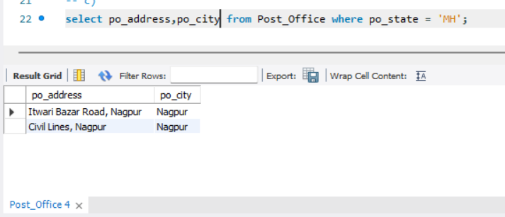

d).In which city having maximum number of post office,show the pincodes of those cities.

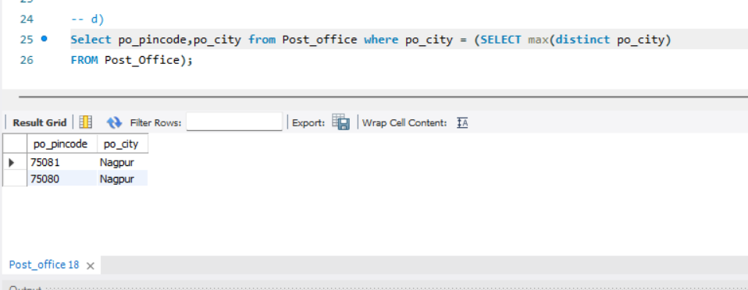

Q2. Create a store procedure that receives the first name of the person table as input and the last name as output. 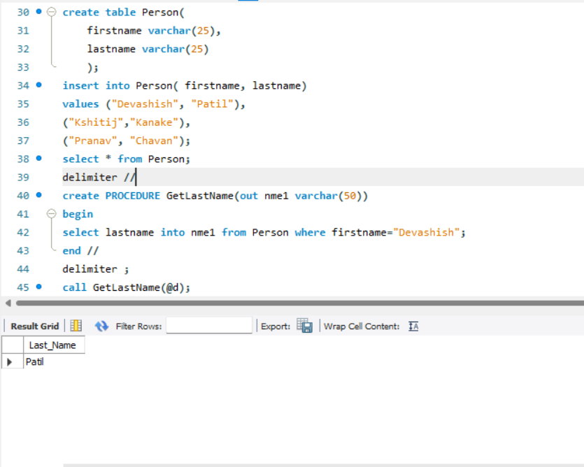

Q3. Create a query to show the account number and customerid from the customer table for the customer without sales orders.

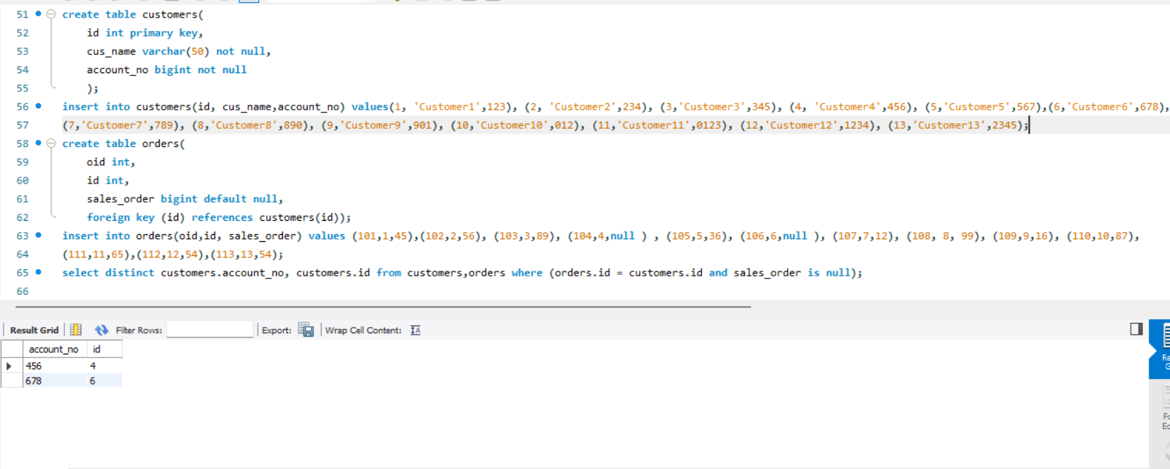

Q4. Create a query to show the top 10 customerIDs of users with more Orders.

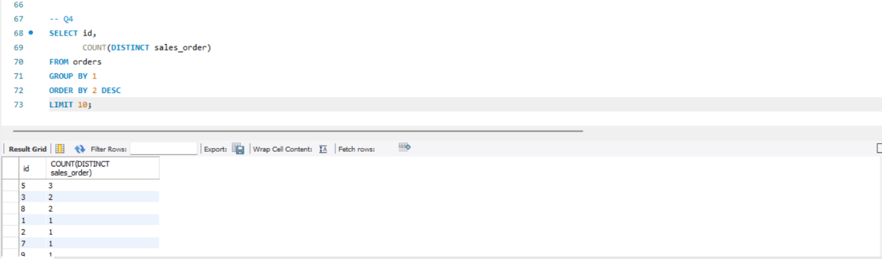

Q5. Creating procedure without parameters

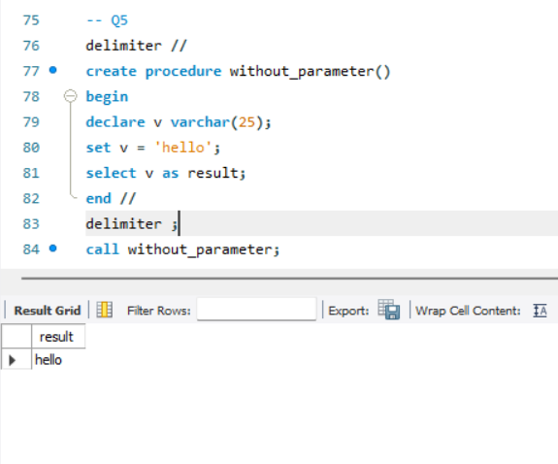

Q6..Creating Procedure with (IN/OUT/INOUT) Parameters.

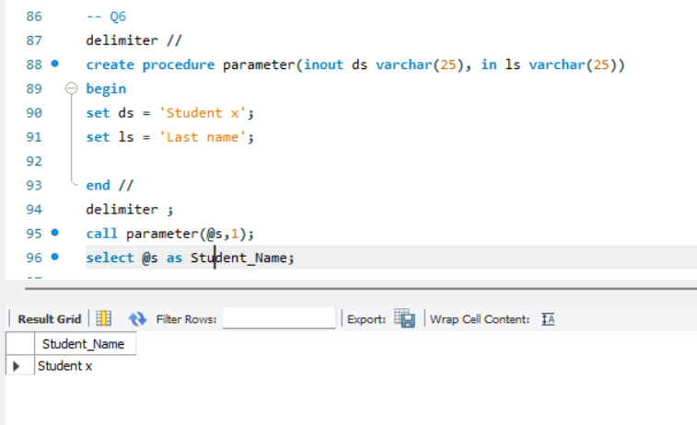

Q7.Write a MySQL stored procedure that takes an integer parameter representing a student's score. Based on the score, the procedure should return one of the following grades using IF-ELSE: i) Score>=90:”A” ii ) Score>=80:”B” iii) Score>=70:”C” iv) Score>=60:”D” v)Score<60:”Fail”

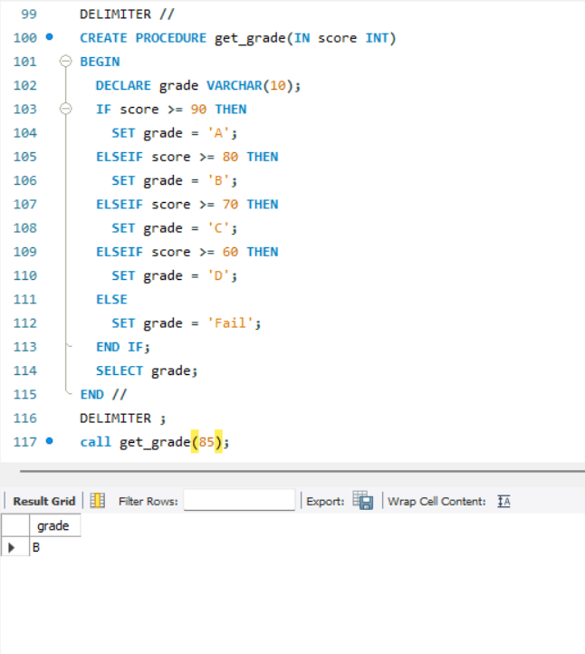

Q8. Write a MySQL stored procedure that uses a loop to iterate through a list of numbers from 1 to 20.

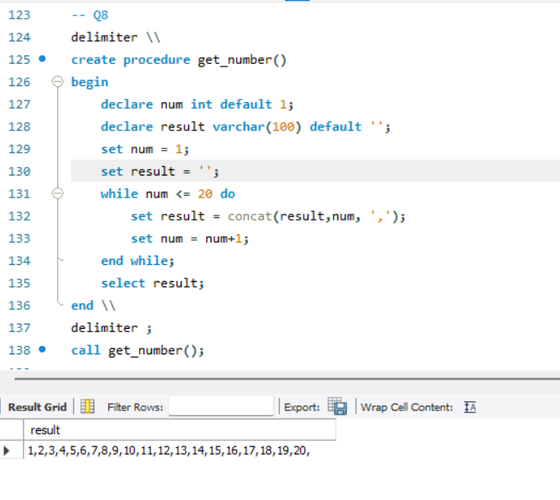

Q9.Create a stored procedure named CalculateFactorial that accepts a single integer parameter, n.Inside the procedure, use a loop to calculate the factorial of n.

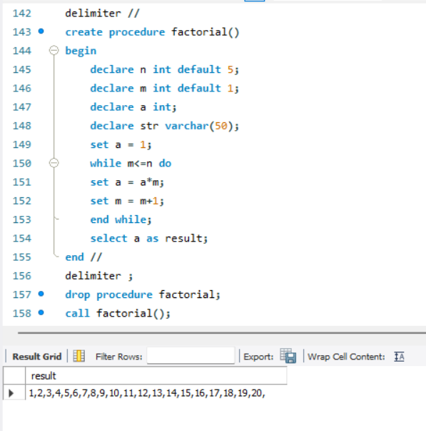

Q10. Create a stored procedure named GenerateFibonacciSequence that accepts a single integer parameter, n, representing the number of terms in the Fibonacci sequence.

